POLLING SYSTEM

 A

Report submitted in partial fulfilment of the requirement for the

degree of

B.Tech.

In

Computer Science & Engineering

By

RITIK GANGWAR (2101641530124)

RISHABH VERMA (2101641530122)

RUBHAM SONI (2101641530125)

ARNAV ASTHANA (2101641530040)

KARAN SINGH (2101641530077)

Under the guidance of

Yashi Rastogi

(Assistant Professor)

Project Id: 22_AIML_2A_10



Pranveer Singh Institute of Technology, Kanpur

Dr A P J A K Technical University

Lucknow

**DECLARATION**

This is to certify that Report entitled “POLLING SYSTEM” which is submitted by me in partial fulfilment of the requirement for the award of degree B.Tech. in Computer Science and Engineering to Pranveer Singh Institute of Technology, Kanpur Dr. A P J A K Technical University, Lucknow comprises only our own work and due acknowledgement has been made in the text to all other material used.

**Date:**

Ritik Gangwar (2101641530124)

Rishabh Verma (2101641530122)

Rubham Soni (2101641530125)

Arnav Asthana (2101641530040)

Karan Singh (2101641530077)

**Certificate**

This is to certify that Report entitled “POLLING SYSTEM” which is submitted by Ritik Gangwar,

Rishabh Verma, Rubham Soni, Arnav Asthana, Karan Singh in partial fulfilment of the requirement for the award of degree B.Tech. in Computer Science & Engineering to Pranveer Singh Institute of Technology, Kanpur affiliated to Dr. A P J A K Technical University, Lucknow is a record of the candidate own work carried out by him under my supervision. The matter embodied in this thesis is original and has not been submitted for the award of any other degree.

|  |  |  |
| --- | --- | --- |
| Signature:     Dr. Vishal Nagar  Dean CSE Department,  PSIT, Kanpur |  | Signature:  Yashi Rastogi  Assistant Professor  CSE Department,  PSIT, Kanpur |
|  |  |  |

**ACKNOWLEDGEMENT**

It gives us a great sense of pleasure to present the report of the B.Tech. Project undertaken during B.Tech. Second Year. We owe special debt of gratitude to our project supervisor Yashi Rastogi, Department of Computer Science and Engineering, Pranveer Singh Institute of Technology, Kanpur for his constant support and guidance throughout the course of our work. His sincerely, thoroughness and perseverance have been a constant source of inspiration for us. It is only his cognizant efforts that our endeavours have seen light of the day.

We also take the opportunity to acknowledge the contribution of Professor Dr. Vishal Nagar, Dean Computer Science & Engineering Department, Pranveer Singh Institute of Technology, Kanpur for his full support and assistance during the development of the project.

We also do not like to miss the opportunity to acknowledge the contribution of all faculty members of the department for their kind assistance and cooperation during the development of our project. Last but not the least, we acknowledge our friends for their contribution in the completion of the project.

|  |  |
| --- | --- |
| Signature  Name: Ritik Gangwar  Roll No.: 2101641530124 | Signature  Name:  Rishabh Verma  Roll No.: 2101641530122 |
| Signature  Name: Rubham Soni  Roll No.: 2101641530125 | Signature  Name: Arnav Asthana  Roll No.: 2101641530040 |

Signature

Name: Karan Singh

Roll No.: 2101641530077

**ABSTRACT**

Voting is a fundamental part of democratic systems; it gives individuals in a community the faculty to voice their opinion. In recent years, voter turnout has diminished while concerns regarding integrity, security, and accessibility of current voting systems have escalated.

E-voting was introduced to address those concerns; however, it is not cost-effective and still requires full supervision by a central authority. The blockchain is an emerging, decentralized, and distributed technology that promises to enhance different aspects of many industries. Expanding e-voting into blockchain technology could be the solution to alleviate the present concerns in e-voting.

In this paper, we propose a blockchain-based voting system, named BC Vote that preserves voter privacy and increases accessibility, while keeping the voting system transparent, secure, and

cost-effective. BC Vote implements a voting framework that utilizes Ethereum’s blockchain and smart contracts to achieve voter administration and auditable voting records. Our implementation was deployed on Ethereum’s test network to demonstrate usability, scalability, and efficiency.

##### TABLE of CONTENTS

DECLARATION i

DEDICATION ii

ACKNOWLEDGEMENT iii

ABSTRACT iv

**Chapter** **1: INTRODUCTION 1**

* 1. Background 1
  2. Problem Definition 2
  3. Objectives 2
     1. Research objectives 2
     2. System objectives 3
  4. Project Justification 3

**Chapter 2: LITERATURE REVIEW 5**

Existing Systems 6

**Chapter 3: SYSTEM ANALYSIS AND DESIGN 8**

* 1. Development Methodology 8
  2. System analysis 9
     1. Feasibility study 9
     2. Requirements Elicitation 10
     3. Requirement specification 11
  3. System Design 13
     1. Conceptual Diagram 13
     2. Context Diagram 14
     3. Data Flow Diagram 15
     4. Use Case Model 16
     5. Sequence Diagram 17

**Chapter 4: IMPLEMENTATION AND TESTING 18**

* 1. Implementation 18
     1. Hardware requirements 18
     2. Software requirements 18
  2. Diagrammatic Representation 19
  3. Testing 22
     1. Integration 22
     2. System Testing 22
     3. Software Testing 22

**Chapter 5: CONCLUSION 24**

* 1. Achievements 24
  2. Constrains 25
  3. Recommendations 25

References 26

List of Appendices i

Appendix 1: Gantt Chart i

Appendix 2: Code Sample ii

Appendix 3: User Manual iv

##### List of Figures

Figure 3.1 Spiral Methodology of Development 8

Figure 3.3.1 Conceptual Diagram 13

Figure 3.3.2 Context Diagram 14

Figure 3.3.3 Data Flow Diagram 15

Figure 3.3.4 Use Case Model 16

Figure 3.3.5 Sequence Diagram 17

Figure 4.2 Diagrammatic Representation 19

Figure A.1.1 Gantt Chart i

Figure A.2.1 The Election Contract ii

Figure A.2.2 App.js responsible for rendering iii

**List of Tables**

Table 4.3.3 Software Testing Report 22

## **Chapter 1**

## **INTRODUCTION**

### Background

Election is a formal group decision-making process by which a population chooses an individual to hold public office or other position.1 Elections have been the usual mechanism by which modern representative democracy has operated since the 17th century.1 Elections may fill offices in the legislature, sometimes in the executive and judiciary, and for regional and local government. This process is also used in many other private and business organizations, from clubs to voluntary associations and corporations. 1

In many countries and organizations with weak rule of law, the most common reason why elections do not meet international standards of being "free and fair" is interference from the incumbent personnel. Dictators may use the powers of the executive (police, martial law, censorship, physical implementation of the election mechanism, etc.) to remain in power despite popular opinion in favor of removal. Members of a particular faction in a legislature may use the power of the majority or supermajority (passing criminal laws, defining the electoral mechanisms including eligibility and district boundaries) to prevent the balance of power in the body from shifting to a rival faction due to an election.1

Non-governmental entities can also interfere with elections, through physical force, verbal intimidation, or fraud, which can result in improper casting or counting of votes. Monitoring for and minimizing electoral fraud is also an ongoing task in countries with strong traditions of free and fair elections.

This shows that despite election being a key and important part of the wellbeing of our society it’s not always performed to the satisfaction of everyone. This calls for coming up with new means of making sure election is free and fair to all. Due to this I decided to come up with this project whereby using blockchain technology which is highly known for its resistance to modification of data to create an e-voting system which will also tackle key voting issues such as voter anonymity, vote confidentiality and end-to-end verification.

### Problem Definition

Election a very important event in a modern democracy. The issue with the current ballot voting system is that it can be easily manipulated by power hungry organizations3. The proposed system looks to eliminate the aspect of trust from an election to make it more secure and transparent. The system uses existing technology such as a client server architecture integrated with a blockchain system to ensure aspects such as transparency, security and auditability are achieved without sacrificing privacy for voters.

The cost of building the system is substantially less as compared to the cost of running a ballot-based system. A single vote currently costs between $7.00 and $25.00, when all factors are considered. A blockchain product like these costs just $0.50 per vote10.

There are also substantial social benefits to using the system as well such an easier and quicker voting process which will lead to higher voter turnout.

This system can be implemented for a larger number of countries as the internet penetration in the world increases. We might definitely see a future where every country has implemented a system similar to ours.

### Objectives

#### Research objectives

* + - 1. Understand how elections are organized with regard to voters’ education and the actual voting process.
      2. Research on what effect does the election process and the results have to the society.
      3. Check how country-specific context variables (e.g. history, political system) affect election

#### System objectives

* + - 1. Requirement gathering on elections, the existing electoral processes, their weaknesses and how to improve them.
      2. Design of the e voting systems architecture which will mainly use blockchain technology and JavaScript for the front end.
      3. Coding of the registration system where users will be able to register as voters using their government issued details.
      4. Coding of the voting system where users will first have to login, cast their vote and also be able to verify and track whether their vote has been cast correctly.

### Project Justification

As seen above, voting plays a vital role in the society and therefore calls for the need of a secure and trusted voting system. The proposed system offers an e voting system using blockchain is justifiable as it provides the following opportunities and benefits over and above the existing voting systems.

1. It is a flexible online solution unlike the existing traditional paper ballot system, that enables secure, cost-effective voting to facilitate shareholder participation and voting from a distance.7
2. Despite the fact that there exist online voting systems at the time of writing, most don’t use blockchain therefore leaving the vulnerable to interference. This is covered as the system is designed using blockchain which is immune to change.
3. It addresses votes tampering, blockchains generate cryptographically secure voting records. Votes are recorded accurately, permanently, securely, and transparently4. So, no one can modify or manipulate votes.5 and might promote more voter participation.
4. Blockchains also preserve participants’ anonymity while still being open to public inspection. Individual votes will be publicly available, while voters are masked behind an

encrypted key. This offers greater privacy and security than traditional ballot boxes and could reduce voter suppression. Bad actors can’t identify voters and therefore can’t target them.6

1. In addition to that, it provides the option of vote verification after the vote has been casted. This is important as it gives the user the option of making sure their vote was casted correctly which is an added advantage over existing systems.
2. Blockchain voting can increase the speed with which votes are tallied. For example, Agora (A Swiss startup which presided over Sierra Leone’s March 2018 general elections) reported that it published election results on its website five days before the official manual counts ended.8
3. The system can eliminate ambiguities. For example, in the 2017 Virginia House of Delegates election, the winner was chosen from paper ballots placed in a bowl. One vote initially wasn’t counted because that voter made confusing marks on the ballot9. Such ambiguity is less likely to arise with the blockchain voting system.
4. The system has a secure login system which prevents people from casting votes on behalf of others. This is key that offers a huge added advantage over existing systems.

## **Chapter 2**

## **LITERATURE REVIEW**

The protection of integrity of digital part of information requires the blockchain technology which is a decentralized and distributed database in a peer to peer network. In blockchain system the data is shared between all the nodes of the p2p network. The data is stored with considering the maximum size and the verification by using a specific technique for hashing. This hashing technique will contain a specific number of zeros at the beginning which represent how many participants does the system has in the network. Transactions are the real data in a blockchain system which are totally public. If the user tries to make a transaction (sending, receiving bitcoins or casting a vote), the system will verify the transaction before adding it to the blockchain. So this verification will prevent the double spending or the fault votes.

In another words, the blockchain can be defined as a list or a decentralized ledger of all transactions that are proceed in a p2p network. Blockchain technology is used in Bitcoin and the other current cryptocurrencies.

In any election, Threats are always existed even if the process of election is paper traditional one or electronic one (e-voting) due to the importance of the results of an election and the high level of stakes for the one who will win the election. On the last decade, a lot of election results has been fraud. The fraud includes some attacks such as double voting, buying the vote and using the blank ballots. So the question is," how to be sure about the results of the election that it's correct and how to find out if it's wrong?” In paper voting, there is always a trusted party which is responsible of counting the votes and the voters must rely on that. In this type of elections, the whole process of verifiability and tallying performed only by the trusted party so the voters cannot find a way to check and verify the correctness of the final results. In “end to end voting verifiable systems”, this whole dependency on a trusted party is reduced in order to give the right to the voter to check and verify the results if it's correct or not.

Using Blockchain as a distributed database for p2p voting system will give transparency due to a reason that the network of nodes will be public and it can take a huge amount of the total computing power in order to modify or change some piece of information which is stored on the blockchain. In Addition, this technology will allow the data to be transparent and not susceptible to corruption. The fact about that blockchain does not have a failure of single point, will make it

most suitable for a voting system. This - 5 - system will be able to verify the quality for each vote to be totally authentic so any election will be secure and transparent. The blockchain can give an exceptionally large and scalable solution to the current voting methods with increasing the security and fraud-proof digital voting. There are many advantages for using a blockchain, which make the blockchain a secure replacement to the other databases.

* High Availability: many nodes totally distributed and storing the whole database.
* Integrity and Verifiability: each chain is verified and then attached to the blockchain. So any altering to some block will affect the whole chain and every block should be recalculated which sound impossible.
* Easy to define one common starting point, where to store the data, always attached it to the last block in the longest chain.

All these advantages lead to build a voting system with blockchain technology.

### Existing Systems.

There are already several systems that try to address this issue such as:

1. Traditional paper ballot system: This is voters make a queue and one by one enter the voting booth where using papers they select their preferred candidates.

##### Weaknesses and Limitations

* + It takes a long time as voters have to make very long queues and the voting process is slow.
  + It is expensive as a lot of personnel are required to oversee the voting process and purchase of the voting materials.
* The results can easily be manipulated by power hungry organizations.

1. Direct-recording electronic (DRE) voting system.

A direct-recording electronic (DRE) voting machine records votes by means of a ballot display provided with mechanical or electro-optical components that can be activated by the voter (typically buttons or a touchscreen); that processes data with computer software; and that records voting data and ballot images in memory components. After the election it produces a tabulation of the voting data stored in a removable memory component and as a printed copy. The system

may also provide a means for transmitting individual ballots or vote totals to a central location for consolidating and reporting results from precincts at the central location. These systems use a precinct count method that tabulates ballots at the polling place. They typically tabulate ballots as they are cast and print the results after the close of polling11.

##### Weaknesses and Limitations.

* + The system overcomes the problem of queues however its main weakness is that it can be hacked and the results manipulated.

## **Chapter 3**

## **SYSTEM ANALYSIS AND DESIGN**

### Development Methodology

Development of e-voting system using blockchain will require a development model that will take into consideration the following fundamental attributes

1. there is a budget constraint and risk evaluation is important
2. The project is a medium to high-risk project
3. Significant changes are expected in the product during the development cycle.
4. There is a need for user feedback

Based on the above attributes, a spiral model of development will be most appropriate. This is because this model allows for incremental releases of a specific product and its incremental refinement through each iteration around the spiral. From its identification, design, construct and evaluation phases as well as their iterations, the project will evolve from a simple concept to a practical use case that will find use in to voting system.

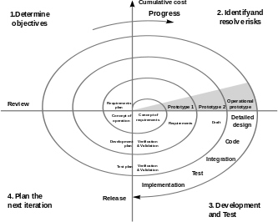

Figure 3-1: Spiral Methodology of Development

### System analysis

Analysis of the information gathered is required to find out the system requirements. This is to clearly define what the proposed system must do. The functional and nonfunctional requirements were defined based on the results of the information gathering.

#### Feasibility study

This is an evaluation and analysis of the potential of the proposed project which is based on extensive investigation and research to support the process of decision making. It assesses the operational, technical and economic merits of the proposed project. The feasibility study is intended to be a preliminary review of the facts to see if it is worthy of proceeding to the analysis phase. From the systems analyst perspective, the feasibility analysis is the primary tool for recommending whether to proceed to the next phase or to discontinue the project.

* + - 1. Schedule Feasibility

It is the measure of how reasonable the project time table is or the deadline is reasonable or not. Development of a complete system is expected to last 9 months. This duration is necessary to facilitate complete:

* + - * 1. Design of the components of the system.
        2. Development of the components of the system.
        3. Creation of relevant documentation.
        4. Acquiring of new skills that are needed to complete development of the system.
      1. Economic Feasibility

The development cost was assessed head-to-head with the benefits it would bring to the current way of operations.

We will use Kenya’s 2017 National elections as our reference point to compare the cost of election using the most popular paper ballot and voting using blockchain. The allocations, at

$25.4 for each of the registered 19.6 million voters, place the Kenya election at the apex of spending on elections in the world, behind only Papua New Guinea ($63), according to data collated from multiple sources. In East Africa, Rwanda is expected to have the most cost- effective election, with the electoral body expected to spend $6.9 million for the 6.8 million voters or $1.05 per voter on average. [12]

This cost is way higher when compared to the cost of voting per voter using Block Vote which stands at $0.50 per voter on average. This is way cheaper and convenient which makes Block Vote the better alternative.

* + - 1. Operational Feasibility

A blockchain voting system is operationally feasible because of the following reasons:

* + - * 1. It enables secure voting to facilitate shareholder participation and voting from a distance.
        2. It addresses votes tampering, blockchains generate cryptographically secure voting records. Votes are recorded accurately, permanently, securely, and transparently. So, no one can modify or manipulate votes and might promote more voter participation.
        3. Blockchains also preserve participants’ anonymity while still being open to public inspection. Individual votes will be publicly available, while voters are masked behind an encrypted key. This offers greater privacy and security than traditional ballot boxes and could reduce voter suppression. Bad actors can’t identify voters and therefore can’t target them.
        4. In addition to that, it provides the option of vote verification after the vote has been casted. This is important as it gives the user the option of making sure their vote was casted correctly which is an added advantage over existing systems.

Development of such a system requires technical expertise and knowledge of aspects of the voting niche. Information regarding this field is widely availed through years of documented research. This therefore creates a suitable operation environment supported by various professionals.

* + - 1. Technical Feasibility

Technical feasibility addressed the availability of technical equipment and knowledge resource required for the development of this project. Fortunately, the software like truffle, ganache, phpstorm and google chrome were readily available and easily acquirable. The hardware for deployment i.e. laptops, were available in multiple versions due to their popularity.

#### Requirements Elicitation

This involves the employment of various techniques to collect information about problems, requirements and preferences about the proposed system. Various techniques were used to gather

information on how the process of project tracking and progress monitoring was carried out. The below techniques were used:

* + - 1. Interviews

A few election bodies’ personnel were interviewed so as to uncover their daily work activities and the difficulties they face. A sample of voters were also interviewed.

The main interview objectives were:

* To determine what challenges face voters during the voting process.
* To determine changes election bodies’ face during preparation and during the voting period. This showed that sometimes the voting process doesn’t always go as smooth as it seems. The system will tackle these issues.
  + - 1. Online research

The internet came in handy during the research of voting systems. This showed that most have lots of loopholes that power hungry personnel might use to manipulate the outcome of the voting to favor them and hence the need of creating a system that efficiently covers these loopholes.

* + - 1. Assessment of similar systems

Systems that were similar in design and some specifications were reviewed. Among these were the traditional paper ballot system and online centralized voting systems. Their features were assessed so as to benefit this new system in terms of improving on its shortcomings.

#### Requirement specification.

Analysis of the information gathered is required to find out the system requirements and its objectives. The functional and non-functional requirements were defined based on the results of the information gathering.

* + - 1. Functional requirements
         1. Online registration of voters who are participating in the election
         2. Secure, immutable voting system whereby users will also be provided with a way of tracking their votes if they were casted successfully.
         3. The system should provide the final tally of the votes and announce the winner.
      2. Non-Functional requirements
         1. Performance - By power of web technology and the Internet of things, the system shall be equipped with mechanisms to promote high levels of performance
         2. Legality - The design, operation and implementation of the system shall be in accordance with all legal provisions contained in the respective area of operation.
         3. Interoperability- The marketing system shall be hosted in the internet and this shall be available to all internet users from a variety of devices and operating systems.
         4. Scalability - The system shall exhibit the ability to handle a growing amount of work. It shall also be adaptive to promising potential and accommodative to complexity and situational sophistication.

### System Design

#### Conceptual Diagram

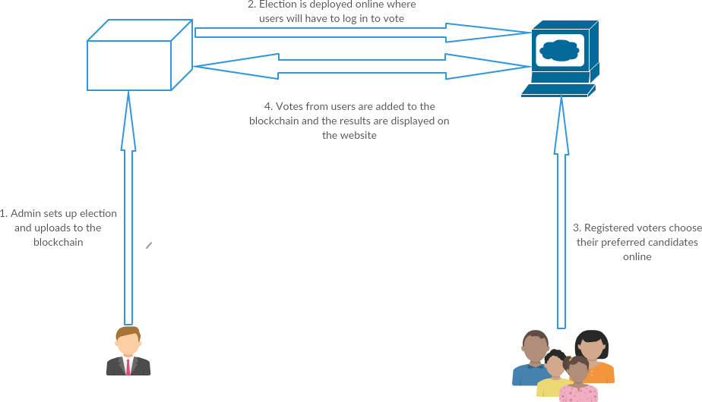

#### Context Diagram

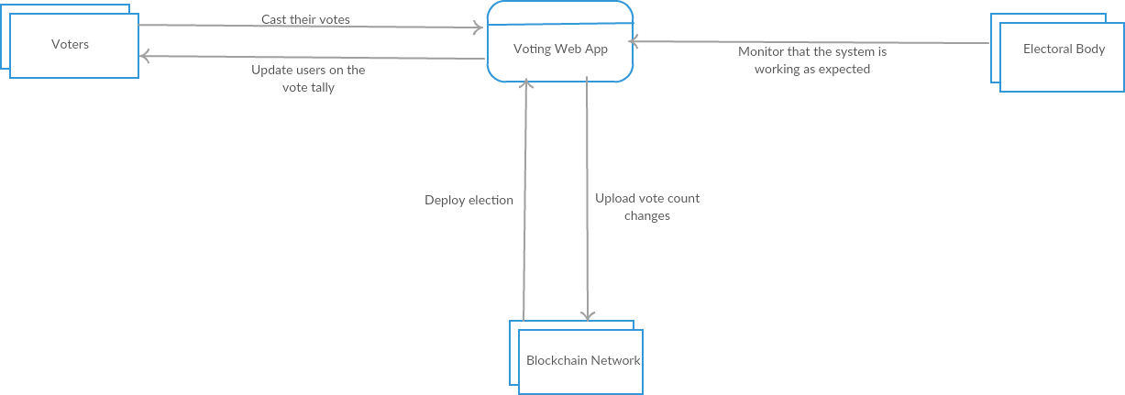

#### Data Flow Diagram

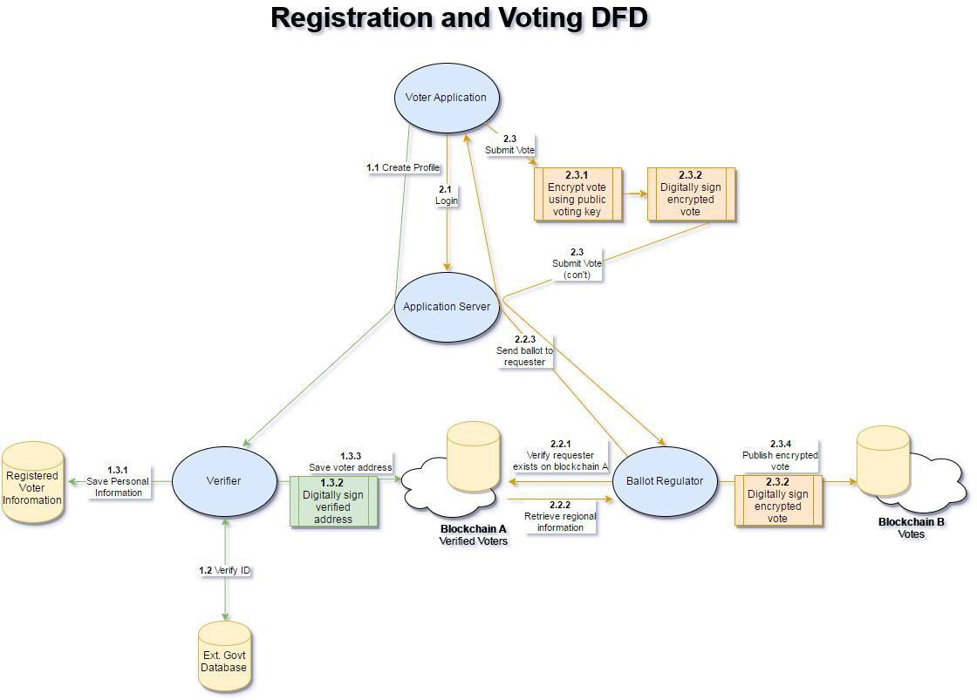

#### Use Case Model

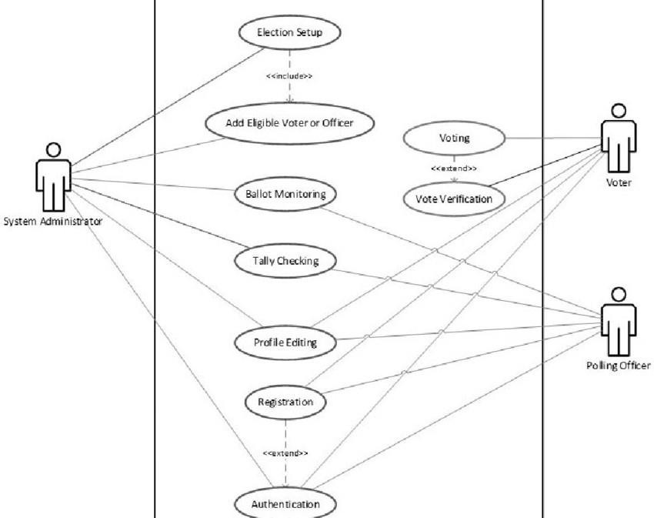

#### Sequence Diagram

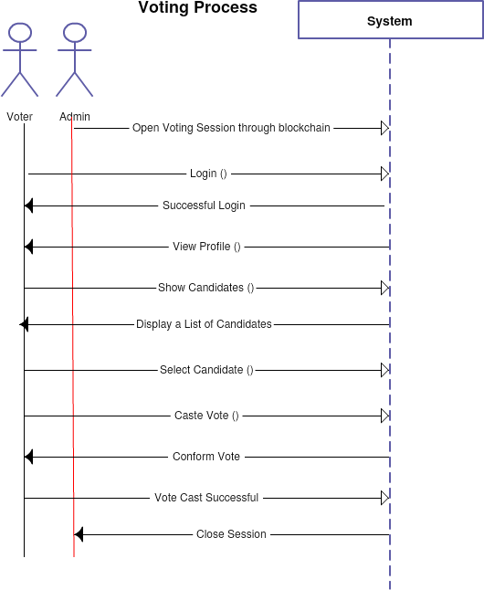

## **Chapter 4**

## **IMPLEMENTATION AND TESTING**

### Implementation.

The system was developed using the following hardware and software requirements.

#### Hardware requirements.

A computer with a minimum of these specifications is needed

* + - 1. 100 MB of free hard disk space.
      2. 1GHz processing speed.
      3. 2 GB Random access memory.

#### Software requirements.

* + - 1. HTML, CSS and JS

This are the base programming language which will be used for the frontend of the system that will be interacting with the blockchain network.

##### Ganache

This will be used to create a local blockchain network which will be used for testing purposes.

##### Web Browser

Most preferably Google Chrome with a MetaMask extension installed, will be used to view the webpages as I design them and also help in testing. It is also my gateway to the internet, where most of the research is done.

##### V.S Code

This is the IDE that will be used to cater for coding purposes.

### Diagrammatic Representation

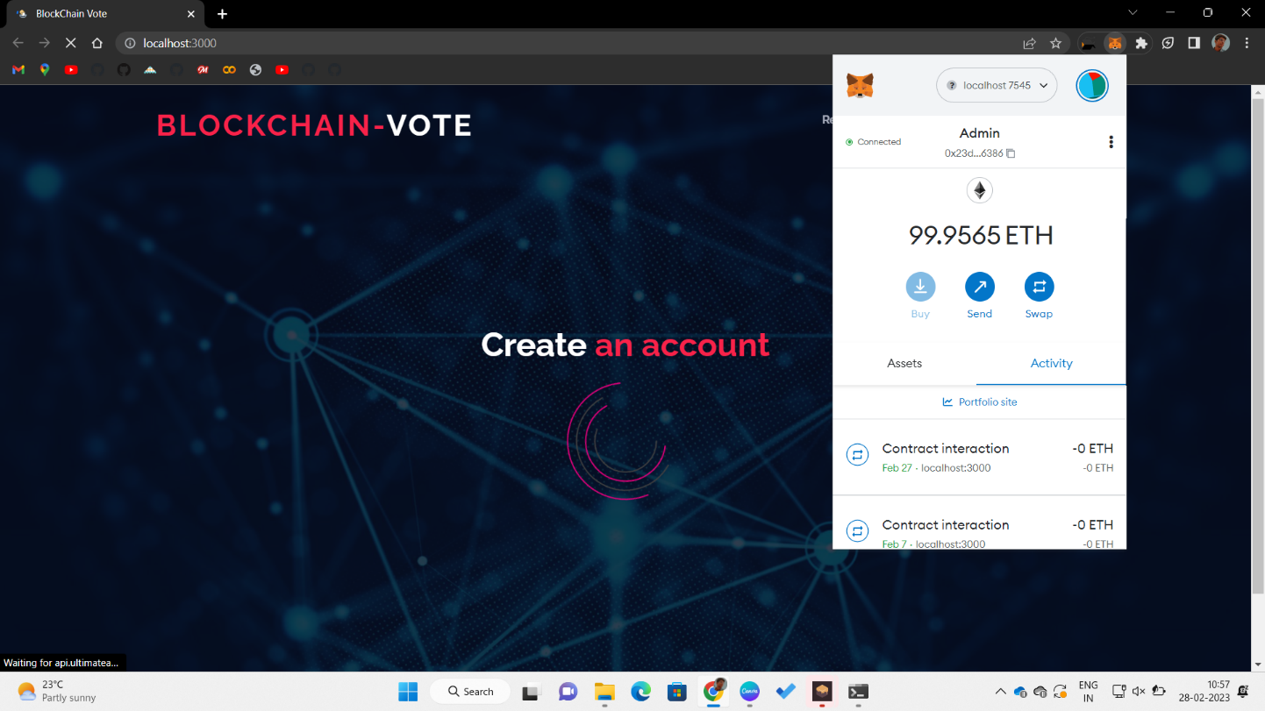MetaMask first asks the user to connect their project to blockchain

Once the user is connected, the admin can now set up the election that is add candidates and start and end the election.

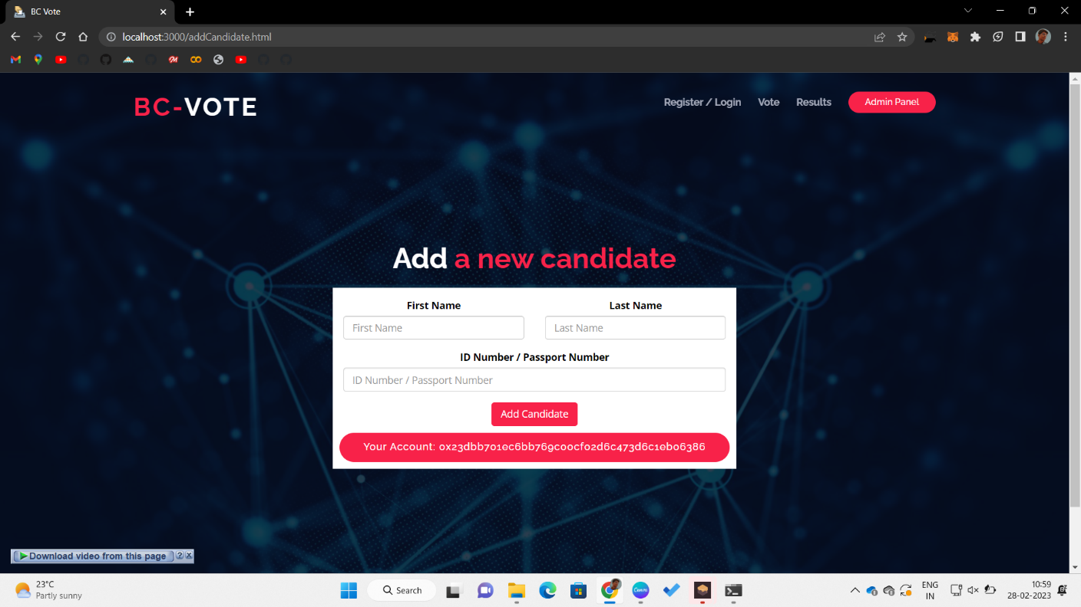

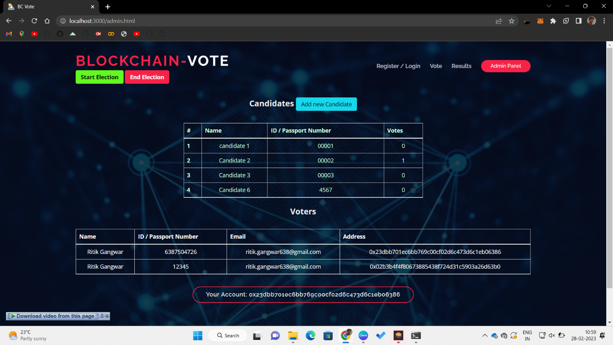The admins can also view the election details such as vote tally and voters’ details.

Once the voting process is deployed voters can register for the voting process.

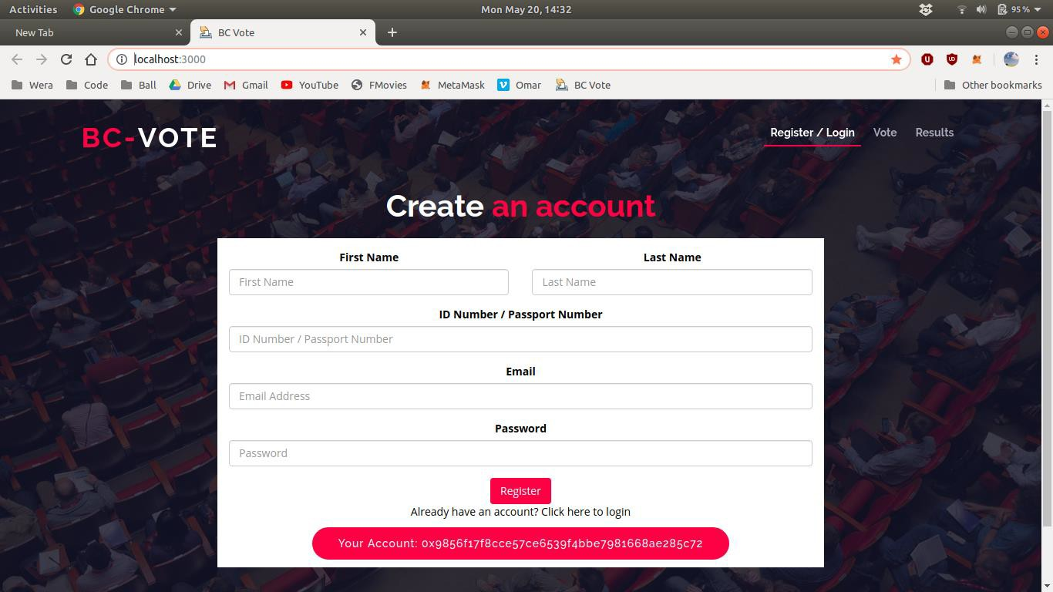

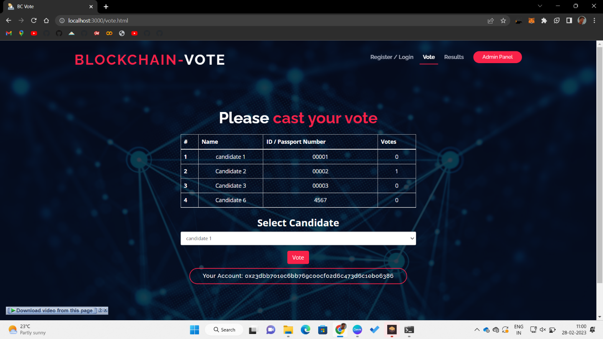Voters will the cast their vote by choosing their preferred candidate.

Results page

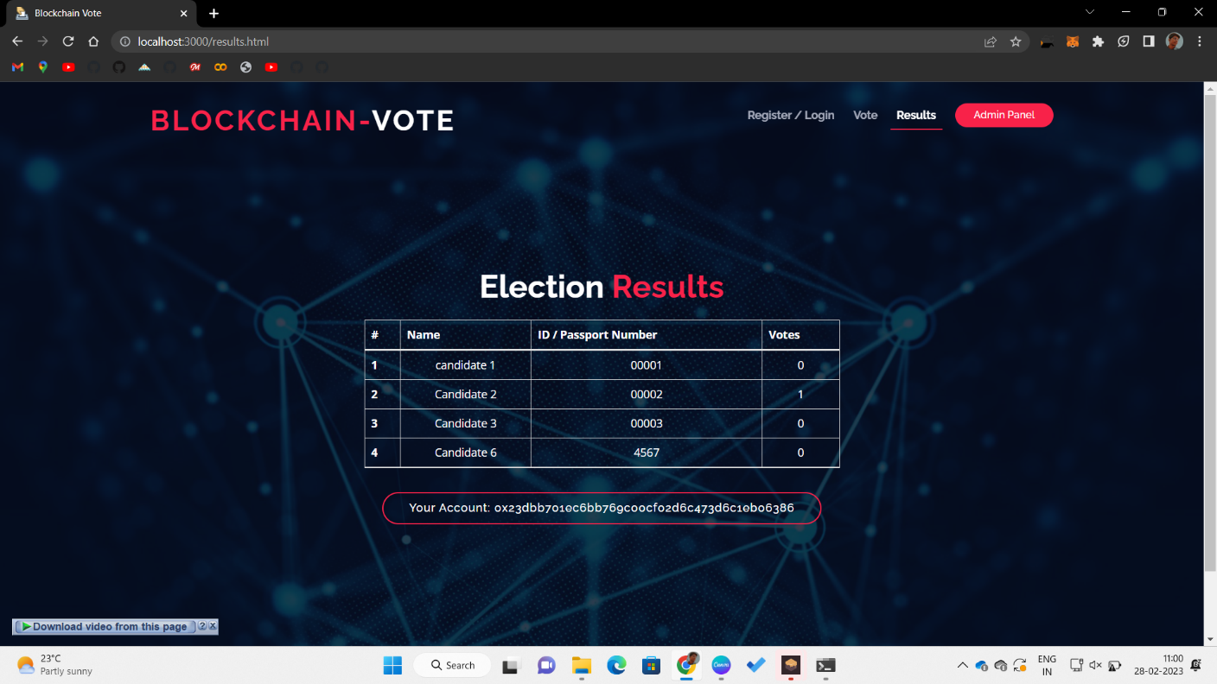

### Testing

Testing refers to examining the software system to identify errors and ensure that the system meets the requirements specifications. The approach in this case includes the Module testing and Integration System Testing. The module testing involved examining the memory dump of the program and using web console of the development browser. This technique was used to test each independent unit for proper functioning.

#### Integration

The individually tested modules were integrated and tested together and errors and bugs collected and corrected.

#### System Testing

The entire system was tested and sample data was input to ensure the proper working of the system and that it meets the requirements of the system and that it is error free.

#### Software Testing

Test Case Matrix for the System

|  |  |  |  |
| --- | --- | --- | --- |
| Test Case | Expected Results | Actual Result | Pass/Fail |
| Login In (Positive Match) | Should positively identify a user and redirect to a dashboard with specific rights that are appended to the user. | Positively identifies a user and redirects to voting page with information about the user. The user also is granted specific rights depending on level of  access. | Pass |
| Login In (Negative Match) | Should decline login request and display a reason why the request was declined. | Declines login request and displays the reason why the request  was declined. | Pass |

|  |  |  |  |
| --- | --- | --- | --- |
| Add candidate | Should be able to add candidate into the voting process | Candidate details are displayed in the voting page where  voters can choose. | Pass |
| Vote | Should able to cast a vote for the preferred candidate. | Voters select their preferred candidate and click on vote.  That candidates vote  count increases by 1 | Pass |
| Check results | Should accurately show the tally of all the votes casted. | Once someone casts their vote they are taken to the results page which shows a  real time vote tally | Pass |
| Can’t vote twice | Should prevent users from casting a second vote once they have already voted. | The select candidate option and vote button disappears once a candidate has  casted their vote. | Pass |

## **Chapter 5**

## **CONCLUSION**

Election is a formal group decision-making process by which a population chooses an individual to hold public office or other position. Elections have been the usual mechanism by which modern representative democracy has operated since the 17th century. Elections may fill offices in the legislature, sometimes in the executive and judiciary, and for regional and local government. This process is also used in many other private and business organizations, from clubs to voluntary associations and corporations.

The issue with the current ballot voting system is that it can be easily manipulated by power hungry organizations. The proposed system looks to eliminate the aspect of trust from an election to make it more secure and transparent. The system uses existing technology such as a client server architecture integrated with a blockchain system to ensure aspects such as transparency, security and auditability are achieved without sacrificing privacy for voters.

The cost of building the system is substantially less as compared to the cost of running a ballot based system. A single vote currently costs between $7.00 and $25.00, when all factors are considered. A blockchain product like this costs just $0.50 per vote.

There are also substantial social benefits to using the system as well such an easier and quicker voting process which will lead to higher voter turnout. This system can be implemented for a larger number of countries as the internet penetration in the world increases. We might definitely see a future where every country has implemented a system similar to ours.

Voting plays a vital role in the society and therefore calls for the need of a secure and trusted voting system .The proposed system offers an e voting system using blockchain is justifiable as it provides the opportunities and benefits over and above the existing voting systems.

In summary, the project was a great learning experience and it would be a plus to see the system being used in real life. Users adopting it will definitely cover many loopholes in the voting process.

### Achievements

* + 1. Creation of a voting system which is fair as it is immutable. The results will be authentic without any manipulation and all the participants will be satisfied.
    2. Development of a voting system which is convenient to use hereby promoting greater voter participation.
    3. Creation of a cheaper voting alterative as compared to the current existing systems.

### Constrains

* + 1. Transactions in blockchain cost a fee. This could affect the users.
    2. Some people are usually reluctant and find trusting online processes difficult. Convincing people that it’s secure and immutable could be an issue.
    3. The system will require good internet connectivity to facilitate connection to remote servers.

### Recommendations.

Efforts should be put in place to encourage use of blockchain to solve problems which affect the society especially where authenticity, integrity, efficiency and confidentiality is key.

## References

1. "Election (political science)," Encyclopedia Britannica Online. Retrieved 18 August 2009
2. Robert, Henry M.; et al. (2011). Robert's Rules of Order Newly Revised (11th ed.). Philadelphia, PA: Da Capo Press. pp. 438–446. ISBN 978-0-306-82020-5
3. Wikipedia, "List of controversial elections," 20 September 2016. [Online]. Available: https://en.wikipedia.org/wiki/List_of_controversial_elections. [Accessed 27 September 2016].
4. G. Prico, “Sierra Leone Pilots Blockchain-Based Voting for Political Elections,” 22 Mar. 2018; https: //[www.nasdaq.com/article/sierra-leone](http://www.nasdaq.com/article/sierra-leone) -pilots-blockchain-based-voting-for - political-elections-cm938309.
5. K. Leary, “Blockchain Might Be about to Change the Way We Vote,” World Economic Forum, 13 Sept. 2017; https://[www.weforum.org](http://www.weforum.org/) /agenda/2017/09/blockchain-could -be- about-to-change-how-you-vote, 2017.
6. . J. Hall, “Can Blockchain Technology Solve Voting Issues?,” Bitcoin Magazine, 7 Mar. 2018; https://www .nasdaq.com/article/can-blockchain -technology-solve-voting-issues - cm931347.
7. . R. DeMarinis, “Is Blockchain the Answer to E-Voting? Nasdaq Believes So,” Nasdaq, 23 Jan. 2017; http: //business.nasdaq.com/marketinsite /2017/Is-Blockchain-the-Answer- to -E-voting-Nasdaq-Believes-So.html.
8. K. Aasmae, “Why Ripples from this Estonian Blockchain Experiment May Be Felt around the World,” ZDNet, 14 Apr. 2016; https://www .zdnet.com/article/why-ripples- from -this-estonian-blockchain-experiment -may-be-felt-around-the-world.
9. B. Miller, “Blockchain Voting Startup Raises $2.2M,” Government Technology, 8 Jan. 2018; http: //[www.govtech.com/biz/Blockchain](http://www.govtech.com/biz/Blockchain) -Voting-Startup-Raises-22M.html.
10. Investopedia, “How Blockchain Technology Can Prevent Voter Fraud”, Jun 4, 2018, [https://www.investopedia.com/news/how-blockchain-technology-can-prevent-voter-](https://www.investopedia.com/news/how-blockchain-technology-can-prevent-voter-fraud) [fraud](https://www.investopedia.com/news/how-blockchain-technology-can-prevent-voter-fraud).
11. U.S Election Assistance Commission. "2005 Voluntary Voting System Guidelines". Archived from the original (PDF) on February 7, 2008.
12. Daily Nation, “Kenya Poll One Of The Most Expensive In The World”, July 17, 2017

## List of Appendices

### Appendix 1:

### A.1.1 Gantt Chart

|  |  |  |  |  |  |  |  |  |  |  |  |  |  |
| --- | --- | --- | --- | --- | --- | --- | --- | --- | --- | --- | --- | --- | --- |
| ID | Task Name | Nov | Dec | Jan | | Feb | Mar | | Apr | May | | Jun | Ju l |
| 1 | Research |  |  |  | |  |  | |  |  | |  |  |
| 2 | Planning |  |  |  | |  |  | |  |  | |  |  |
| 3 | Testing of Alternati  ves |  |  |  |  |  |  | |  |  | |  |  |
| 4 | Choice Implementation plan  and Design |  |  |  |  |  |  | |  |  | |  |  |
| 5 | Module  design and Prototype |  |  |  | |  |  | |  |  | |  |  |
| 6 | Architecture  Design |  |  |  | |  |  |  |  |  | |  |  |
| 7 | Software components design and  testing |  |  |  | |  |  |  |  |  | |  |  |
| 8 | Integration |  |  |  | |  |  | |  |  | |  |  |
| 9 | Overall  Testing and data collection |  |  |  | |  |  | |  |  |  |  |  |

|  |  |  |  |  |  |  |  |  |  |  |
| --- | --- | --- | --- | --- | --- | --- | --- | --- | --- | --- |
| 10 | Review |  |  |  |  |  |  |  |  |  |
| 11 | Documentation |  |  |  |  |  |  |  |  |  |

### Appendix 2: Code Sample

A.2.1 The Election Smart Contract

A.2.2 App.js responsible for rendering.

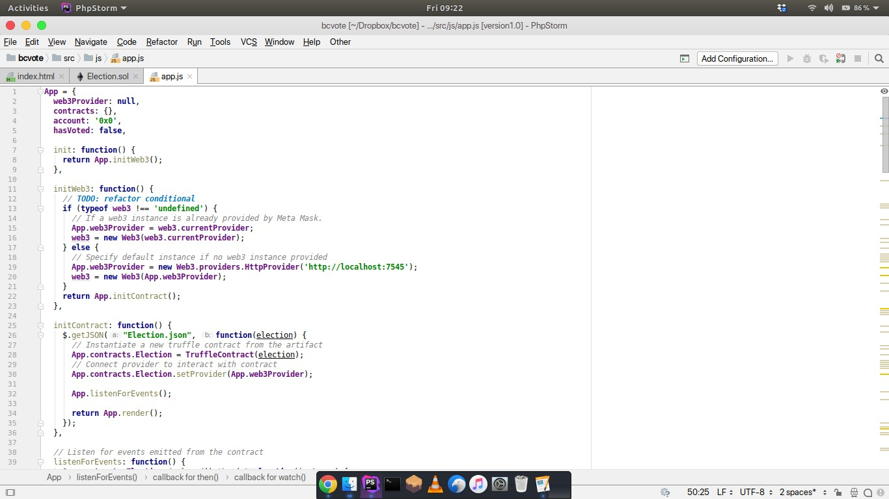

### Appendix 3: User Manual

1. Login into the system.
   1. Open your browser and on the home page, click on metamask extension and a pop up will show
   2. Put in your metamask secret phrase
   3. Press Enter
2. Administrator.
   1. Go to the admin panel and click the start elections button.
   2. Register as a voter first.
   3. Add the candidates that will be involved in the election.
   4. After the voting period has ended, click the end election button and the voting will end.
3. Voting for users.
   1. Open the system and register your details i.e full government names, ID / passport number email and password.
   2. Select your preferred candidate in the candidates drop down menu.
   3. Press the vote button.